1. What is the output for the following program? If there is an error, does it occur at compile time or run time? Also, modify the program such that output is: abd.

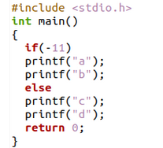

1. How many times is hello printed? Which printf statements are being executed. Give reason for your answer.

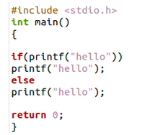

1. What is the difference in the output between program (a) and program (b)? Give reason for your answer.

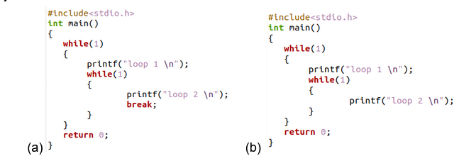

1. (123) base 5 = (X8) base y . Find the possible values for X and Y.
2. Convert the given number (657) base 8 to hexa decimal no
3. Find 2’s complement representation for the decimal number -2502
4. Find the values of the following considering a=45, b=53 and also give the truth table for operators respectively(provide your answer in binary as well as decimal format):
   1. a&b
   2. a|b
   3. a^b
5. Which of the following cannot be a variable name in C?

a) volatile b) true c) friend d) export e) register f) extern

1. Initial values of x, y, z are 1,5,10 respectively. Later

x=y==z; y= (y++)+x; z=(++x)+y+z

What would be the final values of x, y, z respectively after executing the above statements

1. Which of the following declarative statements/ initialization are syntactically incorrect and why (a) int x,y,x; (b) int a1,2,3; (c) unsigned int x=12, y=-23; (d) float x=10, y=x+2;
2. What is the output for the following program? Justify your answer properly

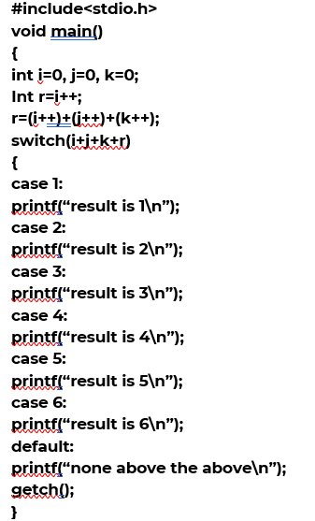

1. Find the output of the below program and justify your answer?

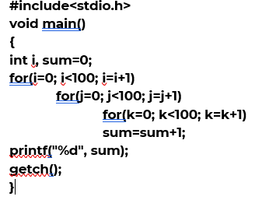

1. **What does the following code do ? Explain with x=7, y=19. Hand simulate all steps and arrive at a conclusion.**

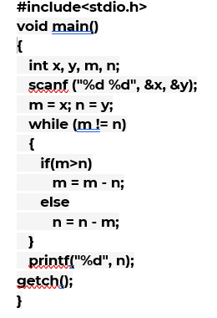

1. (73) base X = (54) base Y. Find the possible values for X and Y.
2. Represent the decimal number -15 in a 2’s complement form?
3. Give the 8-bit signed magnitude representation of following decimal numbers. Include steps followed for each conversion. (2 marks)

A) -9 , B) 50 , C) -100 D) 27

17. Perform binary subtraction using 2’s complement for the following. Check that it is correct by including the decimal equivalents. Include steps followed for each conversion. (2m)

* 1. 1011011 − 10010
  2. 1110110 − 1010111

1. What is the difference between i++ & ++i. Illustrate using an example. And calculate the value of variable ‘x’ for the code given below.

int x=10;

x = (x++) + (++x) +x;

x+=11;

**19.** What do you mean by left shift and right shift. How will you perform left shifting in C-programming. Perform the following ( mention all the steps, do not directly write the answer)

(a)Left shift integer 45 by 3 places.

(b)Right shift integer 44 by 3 places.

1. Write a program to check if a number is odd or even using Ternary
2. What is the output for the following program? Justify your answer properly

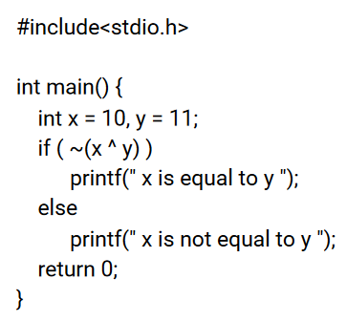

1. Write a ​Program to find the Maximum and minimum of two numbers without using any loop or condition.
2. Find the output of the below program and justify your answer

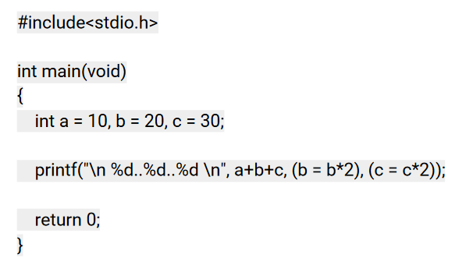

1. Suppose 9 bits are used to represent an unsigned integer. Answer the following:

a. What is the smallest integer?

b. What is the largest integer?

1. Suppose a compiler assigns 2 bytes to store an integer.

Perform the addition of 20 and -30 using

* + 1. 1s Complement Representation.
    2. 2s Complement Representation

1. Find the output of the below program

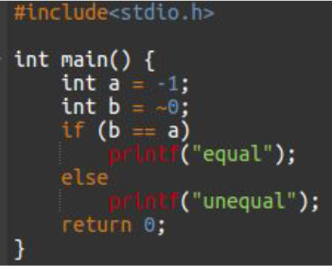

1. Perform binary subtraction using 2’s complement for the following. Check that it is correct by including the decimal equivalents. Include steps followed for each conversion. (2m)
   * + 1. 1011011 − 10010

B) 1110110 − 1010111

28. The smallest integer that can be represented by an 8-bit number in 2’s complement form is

1. The hexadecimal representation of 657 base 8 is
2. Convert the octal number 0.4051 into its equivalent decimal number.
3. What is the output for the following program? Justify your answer properly

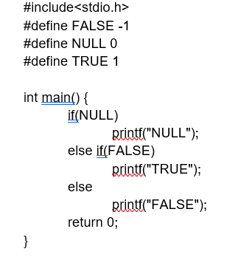

1. Find the output of the below program

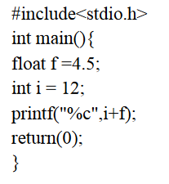

1. What is the output printed for the below statement if the value of c is 7 assigned by

#define c 7

printf(“%d”, (++c) - (c++) );

1. What are the values of ‘Stat’ and ‘var’ after executing the below statement assuming the variable

‘var’ is initialized with 7

Stat =( (++var + var-- << 3 ) >> 2) + var--

1. If the initial value of x is 96, what would be the value of x after performing the following statements respectively

x += 2;

and x =+ 2;

1. How many times program will be printed

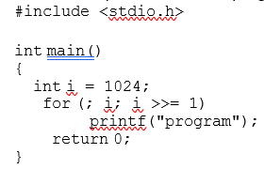

‘

1. Two’s complement represent of -17 is

38. What are the characteristics of an algorithm?

1. The hexadecimal representation of 657 base 8 is
2. Convert the octal number 0.5051 into its equivalent decimal number.